My New Year 2021 Report by Cllr Nigel Moor Gloucestershire County Council
Cabinet Member Environment & Planning

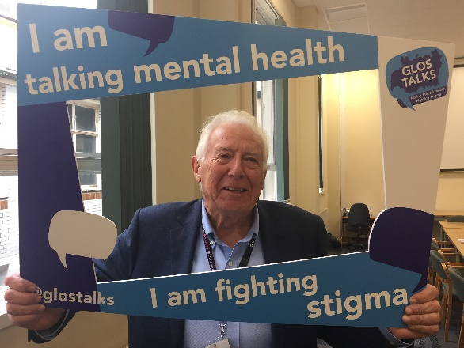
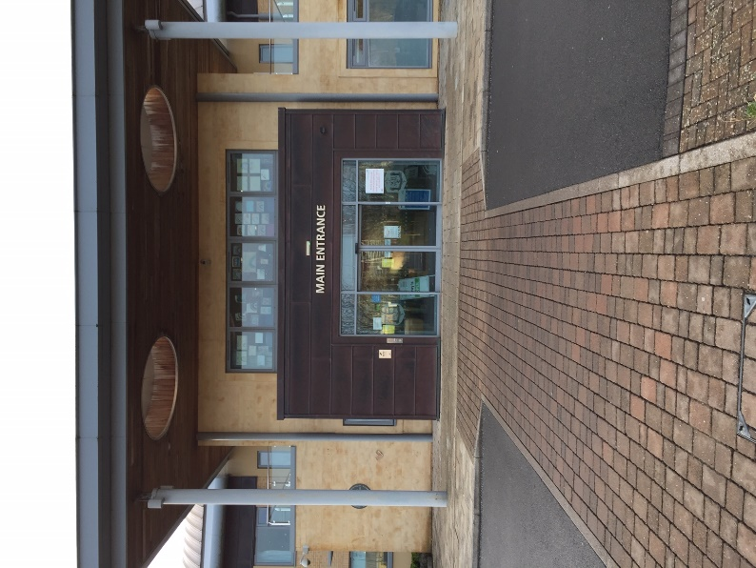
New Year Greetings
This past year has been a very difficult year for us all in the North Cotswolds and some will have lost loved ones or have relatives and friends who have suffered from the coronavirus. But the area has witnessed an extraordinary demonstration of community support and effort. Going into the New Year the tremendous news is that vaccinations have begun at the North Cotswolds Hospital at Moreton. During the pandemic officers, staff and councillors at Gloucestershire County Council have striven to maintain our huge range of services, so as to try and minimise the disruption to our day to day lives. I have been proud to be part of that organisation. In this newsletter I would like to highlight some of the actions and initiatives we have taken that will allow us to go forward to a more optimistic future in 2021.
Best wishes to you all for a more positive year in 2021.
Cllr Nigel Moor

Leading the Response to the Climate Emergency: Gloucestershire Climate Change Strategy Annual Report & Action Plan, 2021/02 – 2026/07
Key points:
The Gloucestershire Climate Change Strategy and 5-year rolling Action Plan was adopted by Cabinet last December. This report summarises the most recent carbon emissions position for Gloucestershire and the council; our progress in implementing the action plan; and proposes an outline action plan to 2026/07.
National data from 2005 to 2018 shows that Gloucestershire’s and each districts’ emissions have reduced broadly in line with those in the SW and for England as a whole, and emissions from the Industrial & Commercial, Domestic and Transport sectors are broadly equal.
I am pleased to report that the council’s corporate emissions for 2019/20 reduced by 73% against our 2006/07 baseline, a decrease of 8% on the previous year. Our Energy from Waste facility at Javelin Park came online in October 2019. Our renewable electricity generated from the facility through to March 2020 brings our net emissions down further to 97% reduction against our baseline. I am pleased to tell you that as a council we will be carbon zero in 2021.
We have made significant progress in implementing the action plan, alongside managing the impacts of the Coronavirus pandemic. Key actions and achievements since the strategy was adopted include:
- Establishing the £1m Climate Change & Air Quality Action Fund to develop and incentivise the adoption of low carbon initiatives and improve resilience to climate change. We have already allocated:
  - £250,000 for grants for community groups and small to medium sized business, to be launched by March next year.
  - £100,000 for community tree planting, to be launched in partnership with the Woodland Trust early next year.
  - £100,000 for School Streets initiatives.
  - £60,000 contribution to Strategic Climate Change Coordinator.
  - £130,000 match funding for our £300,000 bid to the Woodland Trust’s Emergency Tree Fund bid, to bring about at-scale tree planting and woodland creation in Gloucestershire this planting season and next.
- Reallocating road space for cyclists and pedestrians, including securing £1.2m government funding under the Emergency Active Travel Fund, £50,000 from GWR for real time passenger information at Cheltenham Spa Railway station, and allocating £100,000 for developing School Streets initiatives.
- Facilitating a Department for Transport trial of rental ultra- low emission E-scooters in Gloucester and Cheltenham, to support a ‘green’ restart of local travel helping mitigate reduced public transport capacity due to the pandemic. In the first three weeks riders covered over 10,000 miles, equivalent to travelling from London to Sydney.
- Starting work on the Gloucester to Cheltenham cycle lane along the B4063, with works completed in Gloucester along London Rd and Cheltenham Road from close to Great Western Road to Estcourt Road.
- £894,000 for renewable energy generation and energy efficiency improvements to reduce the carbon impact of school buildings investment to increase pupil places.
- Achieving Building with Nature accreditation for our recently adopted Minerals Local Plan, a finalist in the recent South West Awards for Planning Excellence and awarded a commendation in the category ‘Excellence in Plan Making Practice’.
We continue to review every aspect of our business from ensuring school meals come from local providers, to reducing single use plastics and utilising Government initiatives to encourage active travel. We made the switch to a green electricity tariff from September 2019 and our small fleet of electric and plug-in hybrid pool cars are charged using renewable electricity generated by the solar PV panels on Shire Hall.
We will continue to lobby for appropriate powers and resources government to respond to the challenge of climate change, including as a member of UK100’s County Council Network and having signed up to the ‘Blueprint Coalition’ of local government, environmental, and research organisations. This Coalition seeks to secure more powers and resources for councils to take action on climate change and nature restoration, to deliver at scale and to build back better from Covid-19, working together with communities and businesses.

No child will go hungry in Gloucestershire at Christmas

Children in Gloucestershire who are entitled to receive Free School Meals, were supported with vouchers over the Christmas holidays. All eligible pupils who registered and received support during the October half- term automatically received vouchers for Christmas.

Council publishes budget for the future
Gloucestershire County Council has launched a public consultation on its draft budget for 2021/22, after proposals were approved by cabinet in December.
The plans, which total more than £480 million of spending, include additional investment in key areas like children’s services, highways and tackling the climate emergency, as well as planning for the Council’s continued response to the Covid-19 pandemic.
The consultation will run until 5pm on 15 January 2021, and stakeholders across the country including residents, businesses and key partner organisations are being asked to give their views on the proposals.
Leader of the Council, Cllr Mark Hawthorne, said: “We’re proposing a budget that we believe strikes the right balance between investing where it is needed in the here and now, and planning for Gloucestershire’s future. It puts protecting jobs and protecting our environment at its core, and keeps Council Tax levels among the lowest in the country. But we want to know what you think. The decisions the County Council makes will have an impact on all those who live and work here, so your feedback is vital to help shape these plans.
“Please take a moment to fill out our survey, either online or by requesting a paper copy from our customer services team.”
Some of the council’s key investments planned for next year include:
· £1m to make new school buildings carbon neutral
· £9.2m for a new special school
· £15m for the new secondary school in Cheltenham
· £11m for a new primary school in Bishops Cleeve
· £8.1m for improvements to the condition of school buildings and facilities across the county
· A further £4.9m towards delivery of the Gloucester South West Bypass
· £3m towards the £11.6m Cheltenham to Gloucester cycle route
· £11.3m towards M5 J10
· £2.7m investment in new and improved life-saving equipment for GFRS’ firefighters
· £1.8m to ensure delivering Broadband across the county

The draft budget proposes to raise in the region of £6m to help fund services through a 1.99% increase in council tax. The council is also proposing to apply the national social care precept at 2.76% to raise an additional £8.6m. In total these changes result in about a £5 monthly increase for the average Band D taxpayer.
Despite the extra investment, Gloucestershire County Council still expects to have one of the lowest council tax levels of any county council.
The council continues to challenge itself to work more efficiently and effectively and as a result has also identified £7.6 million savings for next year, helping to meet increased demand and costs. For more information and to fill out the survey, go to www.gloucestershire.gov.uk/budget2021-22
North Cotswold Line Update
Following the January 2020 Westminster Hall debate Chris Heaton-Harris MP asked Network Rail to undertake an independent review of the North Cotswold Line Task Force’s Strategic Outline Business Case (SOBC) for the more frequent, faster service on the route between Hereford, Worcestershire, the Cotswolds, Oxford and London.
This was completed over summer of 2020 and the Task Force met with the Department for Transport (DfT) and Network Rail (NR) at the end of October to discuss next steps. The Task Force is now undertaking updates requested by the DfT and NR including an independent review of the scheme’s £199m capital cost, an analysis of the impact of more frequent services on the route’s level crossings, and Covid-19 sensitivity testing. In parallel the Task Force is further detailing de-carbonization benefits, in particular removal of vehicle miles on the south/west Midlands and Oxfordshire highway networks, as well as indices of deprivation, the levelling-up agenda and the fast-increasing housing numbers and active delivery plans emerging in all the 5 counties on the route.
The next step towards expeditious delivery of the scheme is the ‘DEVELOP’ stage of the DfT’s ‘Rail Network Enhancements Pipeline’ (RNEP). This will cost £2.9m, to which the Task Force’s local authorities have committed £0.72m, and we have requested a £2.2m contribution from the DfT. The Task Force’s scheme offers significant benefits across the 86 mile breadth of the North Cotswold Line, including the restoration of direct services from Kidderminster and Droitwich to Paddington. It will also be an essential step to facilitate the Stratford-Honeybourne reopening ambitions which will benefit from the recent government award.
Electric vans now part of fleet to fix streets
Gloucestershire County Council has unveiled three new plug-in electric highways vans, which will be used to help repair roads across the county. Pollution from traffic makes up about 34 per cent of Gloucestershire’s total carbon emissions so the switch to electric and hybrid vehicles plays a key part in the council’s fight against climate change.
The three ultra low emission vans are 100 percent electric, and will be used by highways employees who are out and about inspecting Gloucestershire’s roads. Highways inspectors can drive between 15,000 and 20,000 miles a year. The three electric vans will together save up to 16.2 tonnes* of CO2e** each year.
Cllr Vernon Smith, cabinet member for highways, said, “Switching to electric vehicles where we can is one way to bring down carbon emissions. This is a really exciting and I hope this is an important step in seeing more electric vehicles across the council and across our county. “
Cllr Nigel Moor, cabinet member responsible for climate change, said, “Electric vehicles have a key role to play in helping us cut carbon. Over the last year we have seen a significant take up of electric vehicles using charging points around the county. While we’ve cut the council’s carbon emissions by 97 per cent there’s still much more to do.
“If residents have ideas for possible locations for charging points we would like to hear from you – please email electricvehicles@gloucestershire.gov.uk“
Nick Radford, divisional manager for Ringway, said, “These new electric vans are part of Ringway’s shift towards rethinking highways. We are investing in low carbon and electric vehicles and tools across the whole of our service, and are delighted to bring this innovation to Gloucestershire. Working together, we are investing in highways today, as well investing in new ways of working that deliver a greener future for the highways partnership and local people.”
To outline the replacement planting strategy to following the removal of trees with Ash Die-back on the county highway network
Background
Ash die-back caused by infection of the fungus Hymenoscyphus fraxineus (Chalara fraxinea) is now affecting Gloucestershire after being introduced from the importation of ash trees into other parts of the country. It attacks trees quickly and there is no efficient prevention or curative treatment available. The disease may kill a young sapling in only a single year but older trees will take a number of years to succumb but this is very variable. As ash (Fraxinus excelsior) is a very common species in the county its loss will have a big impact on biodiversity, landscape character and be counter- productive to the objective of planting more trees to combat climate change.

Ash die-back will affect many organisations and people in Gloucestershire but the immediate concern for the County Council will be to protect users of Highways and County Council land from the danger posed by numerous dying trees. The general consensus currently is that between 75% and 95% of ash trees in the UK may eventually become affected by the disease. Some resistant trees are likely to occur but it will take time to confidently identify these.
Current Situation:
To date the Ash dieback project has felled approximately 2,300 trees (of diameter 15cm or greater). We anticipate that we will fell a further 1,900 trees by the end of March 2021. We are also contributing to joint works with the National Trust, Gloucestershire Wildlife Trust and other private estate owners, which will result in the felling of a further 1,000 trees, of which a proportion will be highway trees.

Planting Strategy
This strategy has been developed to reflect the Gloucestershire Tree Strategy which the County Council has recently signed up to. The first principle of this is to Establish the right tree in the right place for the right reason, through both active planting and natural regeneration as appropriate.
We are following Forestry Commission guidance and propose to replant an equivalent number of trees to those felled, however we must consider carefully the location for replanting and demonstrate the benefits of an alternative position for the trees in the landscape.
The County Council is already working with partner organisations in various tree planting projects, and the money allocated for tree planting to replace felled ash trees will be most effective if it is used to supplement the planting through these projects, rather than to try to establish additional projects. Where possible we would like to plant on Highway land, however this approach has to be carefully considered for the following reasons:
• Many of the ash being felled are self -seeded and not in the most appropriate or safe locations on the highway verge.
• Our own monitoring and survey work has shown a good level of regeneration in areas where mass felling of Ash trees on wide highway verges has taken place. Planting may compromise this natural reestablishment of flora.
• We should be taking a risk based and long -term approach. Trees in the highway verge can create a hazard to motorists, and any replanting in these areas needs to be carried out responsibly.
• Identify areas of Highway land where appropriate planting can occur. We are currently investigating several locations including the wider verges of the Fosse Way, and the Cirencester Bypass and similar locations where trees can be planted at an appropriate distance from live traffic.
• Work with Town and Parish Councils to identify possible community tree planting locations. Currently in discussions with Cirencester Town Council, Cheltenham Rotary club, Uley and St Briavels parish councils.

An update on current green initiatives in highways
Background
Gloucestershire County Council’s Climate Change Strategy (December 2019) sets out ambitious commitments for tackling carbon emissions which contribute to climate change. In May 2019 Gloucestershire County Council declared a climate emergency and committed to be net zero by 2030, and deliver a carbon neutral county by 2050, working with partners to deliver an 80% reduction by 2030.
As part of our medium and long -term plans, an action for ‘Identifying ways to reduce our carbon emissions in our highways investment’ was identified. Highway operations are often not traditionally considered an environmentally focused area but there is significant work being progressed in this area.
Initiatives
A number of initiatives are being undertaken across the partner organisations (GCC, Ringway, Atkins, Tarmac, Skanska et al) to reduce our impact on the environment.
There has been an increased focus on waste disposal from highways operations by Ringway and using supply chain and the adjacent contract in Worcestershire to recycle highways arisings; as a result we now recycle or reuse 99% of waste generated through operations in the county. There is a current focus on the area of plastic reduction and recycling and Ringway have introduced a plastic graveyard in each of our depots for a local supplier to collect and recycle. Suppliers have been reviewed as well as packaging of deferred set bituminous material to ensure recycling opportunities are maximised. Most recently, dedicated PPE (Personal Protective Equipment) recycling stations have been introduced in each depot. PPE is then turned into recycled pellets and used for Solid Recovered Fuel.

Within surfacing operations 100% of acceptable material which is removed from the road before the new surface is laid is recycled. (There is a small proportion, around 10%, which is considered hazardous and has to be dealt with using different methods.) Tarmac continues to seek advances in environmental benefits throughout material manufacturing and laying and processes. The initiatives currently include introducing software to track vehicle deliveries better identifying where they are on route allowing real time decisions to be made about running engines on idle for prolonged periods. In addition the use of warm mix asphalt is increasing and Tarmac are promoting its use wherever a more energy efficient manufacturing process can be benefitted from. We are currently investing in electric charging points in the depots to further encourage the introduction of electric vehicles.

Around the important winter gritting service we have carried out an optimisation process to reduce the number of lorries required from 33 to 29. This has maximised the efficiency of the routes and optimised the number of miles being driven when gritting the network, with no change in the length of network actually gritted. There is also a commitment to using Euro VI compliant vehicles across the operational fleet.

The Public Rights of Way (PROW) team have also been focusing on the use of recycled materials and have used a ‘Flexipave’ system on a 2.5mile multiuser trail in Stroud, this utilised over 27,000 used tyres that would have otherwise been sent to landfill. Road planings are also regularly used in PROW and are 100% reused. PROW has also used recycled plastic products in footbridge construction especially where elements are prone to rotting. Another change is that PROW have started is to refurbish signs rather than replace the sign completely, leading to less waste and a longer life cycle for the sign.

Highways land can contribute and improve our local biodiversity providing refuges for some species and links to wider ecological networks in the landscape. We are trialling a number of ways to improve the landscape areas within the highways asset. For example, a trial of yellow rattle is being carried out (which suppresses the growth of grasses), a trial of manual cutting and collecting the grass cut in Andoversford and trials of different planting in central reservations to reduce the amount of grass cutting and improve the biodiversity. Ringway are also working with Plant Life, who are a Wild Flower Conservation Charity to assist with planting options as part of their Road Verge Campaign.

We have also commissioned Atkins to produce an Ultra-Low Emission Vehicle (ULEV) Strategy to provide a policy position for the County to progress actions to enable increases in ULEV uptake. Actions are identified where GCC can Lead, Enable, Explore and Partner others to achieve the overall vision and identify potential funding sources, timescales and methods of delivery. The aim is to enable and facilitate people who make journeys that are unavoidable by motorised transport to make a switch to ULEV’s. The current phase of the project is focused on the implementation in residential streets, but the planned actions are wider ranging. The number and percentage uptake of ULEV registrations in Gloucestershire, user feedback and air quality data will be monitored.

Growing Our Communities Fund
Established in 2018 for the three period 2018/21 this fund enables each county councillor to support community initiatives across their division. I have been able to provide grant to a wide range of parish and community requests across many of the twenty parishes in my division. During the pandemic I have acted as locum for the Winchcombe and Woodmancote division following the untimely death of my good friend Cllr Roger Wilson, and corona virus restrictions preventing a by-election to elect his successor. Both as a farmer and keen walker and a member of the Cotswolds Conservation Board, Roger was passionate in his love of the Cotswolds. I was therefore very happy to support the bid by the Cotswold Voluntary Wardens for The Millennium Man Replacement Project.

The Millennium Man is a chainsaw carved statue of a drover and his dog (see photo), situated on an old drovers way on Langley Hill, Winchcombe. It was commissioned in 1999 by a local farmer's wife and carved from an old, dead, ash tree. Since then it has become a popular landmark with walkers and has been repaired several times over the years by the Cotswolds Voluntary Wardens. Sadly the statue finally collapsed completely last year, when the decision was taken to set up a project to replace it. This project has now been successfully started thanks to generous financial contributions from Gloucestershire County Council's Growing Our Communities Fund, The Wardens Countryside Fund and Winchcombe Welcomes Walkers. The task of carving a new statue, to be called The Langley Drover, has been given to a well known carver from Stroud, Neil Gow, who intends to use a seasoned log of cedar. This new statue (see sketch) should be completed and installed around Easter 2021, with a new base and surrounding wall being provided by the local Cotswolds Voluntary Wardens. Mounted within the surrounding wall will be a metal plaque which will provide historical information about the original statue together with recognition for the financial contributors who made the replacement statue project possible.
