15 Feb 2021
Cotswold District Council asks Bourton-on-the-Water residents for feedback on how to spend new tourism charge
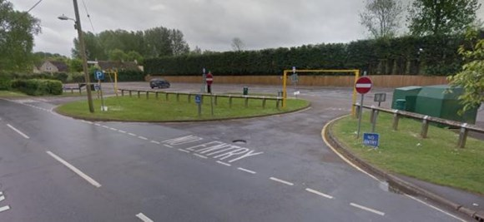
Download

Cotswold District Council is asking residents of Bourton-on-the-Water for their views on how to spend the money raised through a new tourism charge.
For every stay at the Rissington Road car park, 50p will be charged and the Council expects this to raise £25,000 a year. Any additional money generated will be spent in the village with unspent funds carried over for use in future years.
The consultation opens on 15 February and will run for four weeks with residents asked to give their opinions on some initial ideas for how to spend the money and able to suggest their own ideas.
The survey can be found here: www.surveymonkey.co.uk/r/botwtourismcharge
Initial ideas include bollards to stop illegal parking on Rissington Road, more bins to reduce littering and increased litter picking rounds.
The consultation is available through the Council’s website and closes on 14 March. Anyone not able to fill out the online survey can write to the council at Communications Team, Cotswold District Council, Trinity Road, Cirencester, Gloucestershire, GL7 1PX.
Cllr Mike Evemy, Deputy Leader and Cabinet Member for Finance, said; “The tourism charge will raise significant additional funds to spend on projects and activities in the village to manage the volume of visitors who come to enjoy what Bourton-on-the-Water has to offer.
“I would like Bourton residents to respond to the consultation and help us to decide how the tourism charge will be best spent.”
“I look forward to seeing what people think of our ideas and what other suggestions residents have.”
For more information on the consultation, and to fill out the survey, go to www.cotswold.gov.uk/consultations
Contact Information
Cotswold District Council Communications Team
press@cotswold.gov.uk

Downloads
BotW car park

This has been sent to you by Cotswold District Council, we have sent this to you because we believe it to be of interest and that you have consented to us contacting you.

